EVL-4CG(4EZ) Setup and Installation Instructions
Setup Website and Mobile Access (Do this BEFORE installation)
1) Record the 12-digit MAC ADDRESS form the sticker on the EVL-4CG.
2) Visit www.eyezon.com and create an account. (http://www.eyezon.com/ezmain/createaccount.php)
3) Follow the instructions and then log-in to your new account.
4) Click “Add New Device” link on the left side of the page.
5) Click “Begin Activation”.
6) Select “EnvisaLink 4 Honeywell” and click “Next”.
7) Enter the 12-digit MAC ADDRESS that was previously recorded.
8) Give your new Account a name.
9) Read the Terms of Use and select that you have read and agree to them. Click “Next”. (Activation could take a few minutes, please log out of your account, you will return later).
Install the Module to Your Control Panel
1) Disconnect power from your panel if currently running (including any backup battery).
2) Connect the EVL-4CG to the Keypad bus terminals using the wire provided: Vista 20p terminals 4-7, BLACK, RED, GREEN, YELLOW in order. Connect the same colored wires on the other end to the labeled terminals on the EVL-4CG. (Note that the order on the EVL-4CG is RED, BLACK, YELLOW, GREEN.) DO NOT CONNECT THIS UNIT TO THE TIP/RING TERMINALS, IT WILL BE DAMAGED.

3) Mount the EVL-4CG using the three provided mounting pins or in any way that allows the EVL-4CG to be stable, undamaged, and allows for no metal parts (or the base of the chip) to be in direct contact with the can holding your Honeywell Panel (or any other metal devices).
4) Connect an Ethernet cable (not provided) from your Home Router to the EVL-4CG using the RJ45 Jack on the chip. (If there is a commercial firewall, UDP Port 4021, 4022, and 4025 may need to be unblocked)
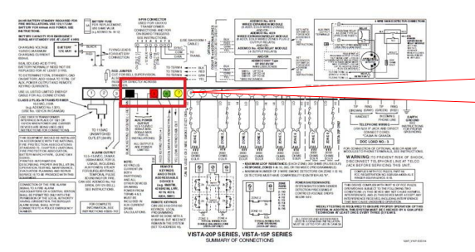
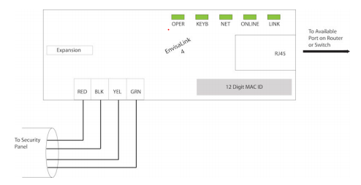
Program the Module and Vista 20P Panel
1) Power up your panel.

2) If you have more than two keypads (assigned to Address 16, 17, 18, etc., it would be best if the keypad assigned to address 18 was switched to another address using the same technique used to program it originally, including activating that device number in the *190-*196 programming range. This allows the EVL-4CG to run properly with no changes, since it addresses itself to Address 18 automatically.
3) Once you have programmed your Vista 20P Panel properly in all other aspects (From the 20P Manual) follow the next steps to properly update that program for the EVL-4CG:

A. Enter (Installer Code from 20P Manual) + 800 to access installer programming mode. “20” should appear on the display.
B. *191 enter 10 to activate Device (Keypad) Address 18
C.*29 Enable IP/GSM (IP/GSM/LRR support required for your Envisalink4 to transmit alerts): Enter 1*0*.
D. *48 Report Format: Enter 77
E. *49 Split/Dual Reporting: Enter 5 and you will hear 3 beeps.
F. *50 Burglary Dialer Delay: Enter 0 and you will hear 3 beeps.
G. *54 Dynamic Signaling Delay: Set to 0 and you will hear 3 beeps. H. *55 Dynamic Signaling Priority: Set to 1 and you will hear 3 beeps.
I. *59 Exit Error Alarm Report Code: Set to 0 and you will hear 3 beeps.
J. *60 Trouble Report Code: Enter 10 and you will hear 3 beeps.
K. *62 AC Loss Report Code: Enter 10 and you will hear 3 beeps.
L. *63 Low Battery Report Code: Enter 10 and you will hear 3 beeps. M. *64 Test Report Code: Enter 10 and you will hear 3 beeps.
N. *65 Open Report Code: Enter 110 and you will hear 3 beeps.
O. *66 Arm Away/Stay Report Code: Enter 111100 and you will hear 3 beeps.
P. *67 RF Transmitter Low Battery Report Code: Enter 10 and you will hear 3 beeps.
Q. *70 Alarm Restore Report Code: Enter 1 and you will hear 3 beeps.
R. *71 Trouble Resolve Report Code: Enter 10 and you will hear 3 beeps.
S. *73 AC Restore Report Code: Enter 10 and you will hear 3 beeps.
T. *74 Low Battery Restore Report Code: Enter 10 and you will hear 3 beeps.
U. *75 RF Low Battery Restore Report Code: Enter 10 and you will hear 3 beeps.
V. *84 Auto Stay Arm: Enter 0 and you will hear 3 beeps.
W. Enter *99 to exit programming.

4) After a few minutes your EVL-4CG should now have 5 solid green LED lights lit up. (The Link light will flicker with communication activity).

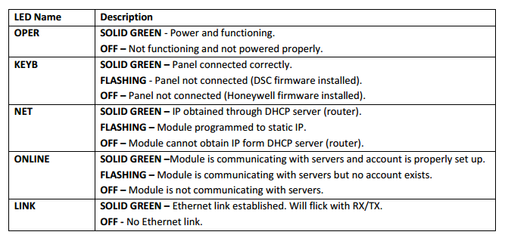

Complete Setting Up Your Eyezon Account and Add Notifications

1) Sign in to your Eyeson.com account.

2) At the bottom of the left side menu should be your recently named House Icon. Click the house.

3) If you have done the previous steps correctly your STATUS will be displayed and any troubles will show if you hover your mouse over the word TROUBLE. You will also now have the option of controlling your alarm from this webpage.

4) Press the “Account Settings” link to review or change your information. If you find your events are reporting the wrong time please check your “Time Zone” settings here as well.
5) Click the “Manage Contacts” link to access the Contact Manager. By default, the email address you used to create the account will be set-up as your first contact, however it is not enabled to receive any alerts. You can add more contacts as needed.
6) For adding devices to notifications click “Create New Contact”. You can type a “Name” and then enter the email address, or you can select SMS and enter a phone number and select a carrier. Click “Add Contact”.
7) When your contact is first created, it will be listed as “Not Verified”. All contacts must be verified before they will work. When you created a contact the system sends a link or a PIN depending on the type of contact created. For email, it sends both a link and PIN, for SMS just a PIN. If your contact was an email the recipient can just click on the link to verify the contact or you can enter the PIN in “Manage Contacts” and click on the name you gave the contact (It should currently say “Not Verified”). If SMS you must have the recipient contact you and tell you what PIN they received so you can enter it here.
8) To enable and edit a contact to receive alerts from your system you must click the “Assign Devices” button in the contact details area. After pressing “Assign Devices” you will be presented with a list of devices available for that contact just press “Enable” beside the device.

9) Select the Alerts you want that device to receive and the format and click “Set Alerts”.

10) In order to control your alarm panel from your phone you must create a Mobile Portal Link. Click “Mobile Portal Link” on the left column menu. Then click “Create Link”.

11) Once you have done that you will see your new link. You can then email that to your phone. (Note: only one link can be active at a time, if you make a new link the current one will be not work anymore). If you want someone else to have mobile access to your account simply forward the current link to them i.e. everyone must share the current active link. To get your Mobile Portal Link to appear as an icon like any other App just bookmark it to the desktop (on most phones in the browser menu it would be “Add To Home Screen”) Use this icon to Arm and Disarm your system from your phone.

Troubleshooting Tips

1) Do Not Know Installer Code
Step 1: Shut down the system.
1. Shut down transformer.
2. Shut down battery.
3. Leave system off for 60 seconds
Step 2: Bring the system back up.
1. Repower the transformer.
2. Repower the battery.
Step 3: Force system to programming mode and retrieve existing installer code.
1. With 30 seconds, push and hold the * and # keys together on a keypad.
2. Hold for 2 seconds and the 20 should appear on the display which indicated you are in programming mode.
3. Enter #20 and the display will show the existing installer four-digit code, one digit at a time.

2) Error Messages
If errors were made during programming; error messages will appear under the System Screen in your EyezOn account. On Honeywell systems, there are two errors that can be encountered once programming is complete:

1. Error: Possible Keypad Conflict or Keypad Programming Not Complete
If you receive this error, address 18 has not been enabled properly on your Honeywell Panel during programming. Verify that the Envisalink4 address has been enabled on the panel by going to its section as outlined above The Envisalink4 is address 18, so you would go to section *191. Verify that the data in the keypad programming section has been set to 10. If not, set it to 10 (meaning Partition 1 and no audible messages). The error will now be gone and the partition(s) will now show under STATUS.

2. Error:*29 Programming on panel not completed properly
If you receive this error, the long range radio (LRR) feature has not been programmed properly. The feature is required for your Envisalink4 to transmit alerts. To enable this feature, see Program the Module and Vista 20P Panel section 3.C. Once the LRR feature is enabled, the error message will disappear and Partition Status will show as Ready.

If you have any questions or concerns, or have trouble activating your account and setting up customers, please email our Help Desk at SteveQ@alarmliquidators.com or call 610-242-3975. Note that phone support is only available, Monday-Friday 9am-4pm EST.

